SentiBots
Smart, centimeter-sized swarmbots

Sundaramahalingam Sudharshan
NUS High School of Math and Science
Singapore
sudhar393@gmail.com
Isaac Tay Eng Hian
NS High School of Math and Science
Singapore
isaactay3@gmail.com

Abstract— In current swarm systems, quadcopters are commonly used as flight platforms. However they are unable to be effective platforms due to the lack of swarm optimized features like compact design and enclosed moving parts for close interaction in swarm systems. We propose a solution in the form of a hardware and software optimized swarm platform. By designing a unique frame which encloses the electronics and increases durability and resistance to mid-air collisions, we managed to make a hardware optimized swarm platform. Furthermore, by experimenting with different control algorithms, we managed to optimize the software of the platform. Results indicate that the optimization greatly helps to improve performance by allowing the swarm to be more dense due to the more compact and resilient design. We are also able to widen the applications as the pooled computing allows the platform to make complex decisions otherwise not possible with individual computers. This will drive the swarm intelligence industry to greater heights as an optimized swarm platform is critical for research applications.

Introduction
This project aims to achieve a hardware and software optimized swarm flight platform that allows for swarm developers to have an easier time developing and using swarm platforms in real life applications.
Current swarm platforms mostly use conventional quadrotors for their applications. However, conventional quadrotors have several problems when confronted with swarm activity. These problems inhibit the abilities of these swarm platforms as their structure inherently prevents the close interaction of swarmbots in swarm behavior.
Quadrotors use four propellers to generate thrust and variable speed control for movement. The inherent design has it that there are 4 propellers spinning at high speed which are exposed. In a swarm environment, where the drones have to fly in close proximity, these propellers are highly likely to cause a mid-air collision. Furthermore, quadcopters carry heavy equipment and take up huge batteries with not much efficiency as they need to drive 4 motors. This decreases the flight time and increases the size and both of these are undesirable in swarm platforms.
Our swarm platform, SentiBot, uses a new drone design to solve the inherent problems with the quadrotor while maintaining the versatility of the quad. It also adds resilience and durability to the frame. Close-range flying is no problem with this frame as all the moving components are contained within the frame.
We also experimented with intelligent software which allows us to analyze the performance and make improvements as required. By creating an optimized platform for swarm research, we hope to accelerate the progress in swarm research and allow for swarm research to be applied in industrial and civil applications.

Hardware Design

Introduction
We have implemented several new designs and strategies to optimize the hardware performance on the SentiBot. By using the novel frame design, we are able to contain the delicate electronics inside the drone while also providing a certain element of modularity. By implementing a custom electronics design, we are able to shrink the control and processing electronics to make the design more compact. These improvements coupled with the software give us a highly optimized swarm platform.

Analysing the features of a good swarm platform
We first analyzed existing swarm research to determine the problems researchers put forward while dealing with quadcopters in swarms. We found out that swarm formations where greatly affected by the prop wash of propellers affecting each other. This is due to aerodynamic interactions between adjacent quadrotors and this causes inability to closely interact with one another. Thus minimizing planar aerodynamic interactions was a focus of our research. Furthermore, the ability for a swarm to interact with one another also comes from small size as more robots can be fit in a certain volume which can increase the swarm density and efficiency.
Another problem that many researchers hinted at was the cost and effectiveness issue. Almost all attempts at commercial swarms have been hindered by the overwhelming cost of implementing such a system which outweighs the benefits of a swarm system. This is a major problem we tried to tackle and solve as quadcopter can be not economical for use in swarms.
The ability to easily modify a quadrotor to add and remove sensors is important for a swarm platform. The swarm platform needs to be multi-purpose to allow the swarm to multi-task and for the swarm to serve multiple purposes at the same time.
In conclusion, the main factors that make a good swarm platform are size, cost and modularity.

Flight drive system
The novel frame design on our SentiBot platform is one of the reasons for its ideal characteristics for swarm activity. Our frame design goes against the conventional design of 4 motors by replacing it with a custom counter rotating EDF (Electronic Ducted Fan). This reduces the number of high-speed moving parts on the design and therefore lowers the complexity and chance of failure. By using an EDF instead of a propeller design, we also managed to get much better static thrust performance which is ideal of hovering in these types on drones.

The counter rotating blades negate the counter-torque effects that might have been present in a single motor design such as the Spherical Flying Vehicle.

Control system
For control, we went for 4 control surfaces much like a conventional coax-copter. These control surfaces work much rather in the same way as airplane flaps and direct air to achieve control. By enclosing the whole design in a cylindrical shaped frame, we enable the frame to contain all the essential electronics inside the frame and prevent damage to the moving components.

Flight efficiency measurements
By employing, high speed motors with bullnose propellers, we are able to achieve the max efficiency for a similar sized drone. At a max thrust of 800g running a 4s(16.8V) Lithium Polymer battery, the SentiBot is the smallest ever created drone of its kind. Other drones that employ the coaxial motors and the control surfaces, are many orders of magnitude bigger due to the inability to achieve this much thrust per space occupied.

Modularity
Using the cylindrical design as a reference point for the design, we added modularity by ensuring a complete bolt based design. The SentiBot can be easily accessed with just a hex driver. You can also easily get access to the main processing board by just removing the top cover, allowing researchers to easily access the electronics to experimentation.

Enhancing large scale manufacturing
Lastly, the frame design allows for easy large-scale manufacturing. The 3D files which make up the components in the frame are simple 3D shapes that can be easily molded and cast thus making it easier to manufacture for research purposes. As of now the frame uses a polylactic acid (PLA) material, but this material could be changed to more durable ones like polycarbonate or Nylon-6. In conclusion, the frame design allows for a durable and modular swarm platform which is able to be easily implemented into swarm systems.

Electronics Design

Main Processor
The electronics design is a critical part of the platform as the electronics provide the foundation for the control system of the robot. Since the robot is intended more for use in computing power intensive applications like search and rescue and swarm intelligence, it is paramount that we have a processor on board. Our processor of choice was the Intel Edison. It provides a decent amount of computing power operating at 500MHz with 512MB of RAM. It also has 4GB of onboard storage for any applications or programs. Since it runs a version of Debian Linux, Ubilinux, it makes it very easy for you to program it.

ATMEGA 328 and lower level processing
We realized that we needed a separate microcontroller to manage the control logic to avoid too much pressure on the Edison. We ended up using the ATMEGA 328 microcontroller chip and flashing the control logic onto it. By using a ATMEGA 328, we also obtained additional sensor expandability options through getting more GPIO which could be used.

IMU(Inertial Measurement Unit)
The control loop also required an Inertial Measurement Unit (IMU) to detect orientation and compensate for oscillations present in the frame. By using an I2C interface to the ATMEGA 328, we managed to connect the MPU6050 and a barometer to the chip which allows for the chip to compensate for oscillations. This will also help to stabilize the frame as seen in the following section. The MPU6050 is connected to the custom PCB through a set of header pins which allows the IMU to either be temporarily or permanently connected to the PCB.

Flight Drive system specifications
The power electronics consists of 4 1C 1200mAh batteries, 2 30A super light ESC’s and 2 4000kV 1306 motors. The motor have a max current draw of 8A each and taking into consideration that the max thrust of each motor is 370g the gram per current rating for each motor is 46g/A. Since the weight of the SentiBot is about 320g, the nominal current draw during a hover would be about 7A. That gives us a flight time of about 10-15min. This is a pretty respectable amount of flight time for a conventional drone. This configuration can of course be changed in case the user requires more power or more flight time.

Power Supply management
Lastly, I would like to talk about the power management system in the SentiBot. We will be using the in-built BEC in the ESC which provides clean 5V out to power the board. The board also has an onboard 3V regulator to provide power to the Edison and the logic level converter which allows UART communication between the 1.8V Edison and the ATMEGA328 for the Edison to send high level commands to the ATMEGA 328 controller.

Software Architecture

PID Loop
The control algorithm used in the SentiBot is similar to all the other control algorithms used in typical quadcopters. Implementing the classic PID control loop, we allow the sensor data to be mapped into error values that can be used to compensate for frame errors and instabilities in the frame.

The control algorithm first reads the I2C bus and outputs the data from the IMU which has been preprocessed by the Digital Signal Processor (DSP) on board the IMU. This allows for the control algorithm to get filtered and processed yaw-pitch-roll (ypr) data for use in the PID algorithm. The processed ypr values are sent through the respective PID loops for their specific axis and used to obtain 3 error values for each of the x, y and z axis. These error values can then be used to output to the servos, which then tries to bring the system back to the stable state by moving the specific servos. The barometer also enables altitude hold using another PID loop. All of the control algorithm runs onboard the ATMEGA 328.

Android Application
The android application allows for us to take manual control of the SentiBot to conduct testing and provides a basic debug window amidst other features to make debugging easier. It is using a simple UDP interface and connects to the Edison via WiFi which allows us to issue instructions to the SentiBot.

Lack of Software research
Revisiting the aim of the project to create a swarm optimized platform, the aim of the project is more focused on the hardware aspect of design such a platform and the software is more of a complementary feature to allow for testing to be carried out. The lack of focus on actual swarm implementation explains the lack of software research in this project.

Software flow diagram
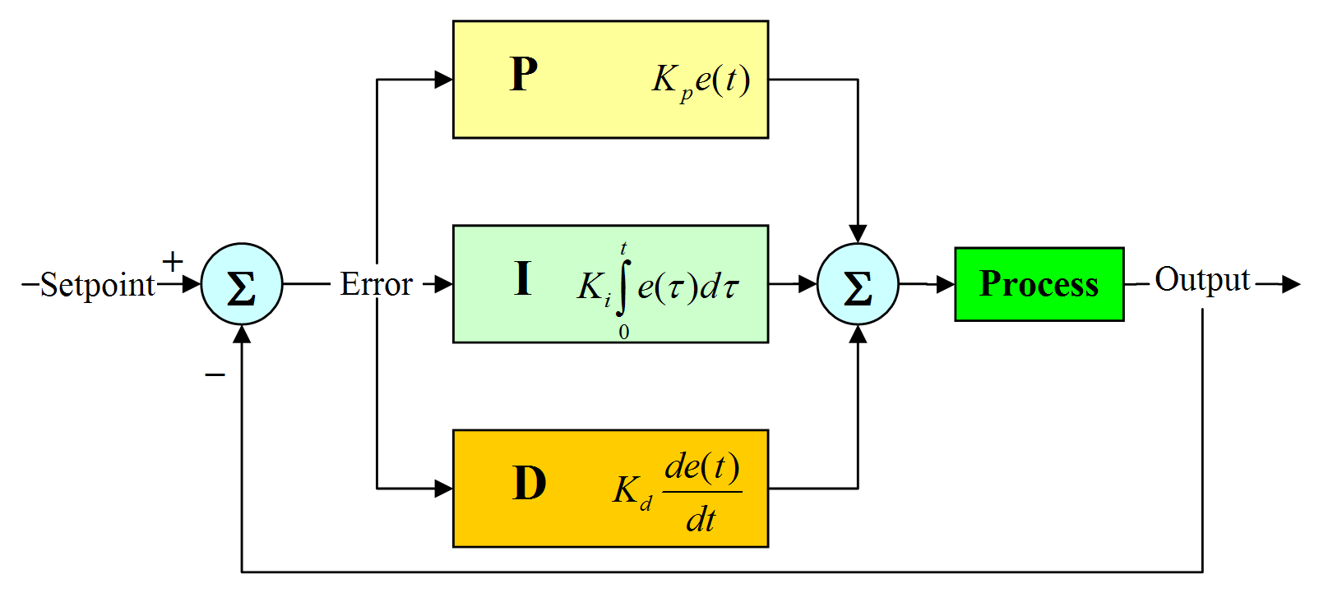
Intel Edison
Vision
Algorithm
Swarm
Algorithm
RX/TX serial communicatoin
ATMEGA 328
PWM outputs to Servos and Motor
Inertial Measurement Unit
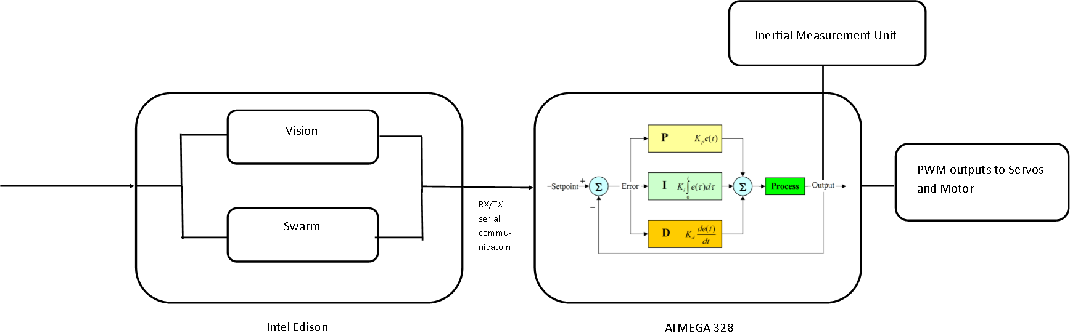

Potential Applications
There are primarily 3 applications that a SentiBot swarm could be used in and their respective possible implementation plans are discussed below.

Search and Rescue
Search and Rescue is a prime application for SentiBots as the small size of the SentiBot make it ideal for search and rescue. With the ability to move through small air ducts, and squeeze through small location in a collapsed building, SentiBots has a significant advantage over larger quadcopters.

By having a completely enclosed unique frame design, SentiBot offers high durability and the ability to operate in harsh environments which also makes it ideal for Search and Rescue.

The swarm ability of SentiBots gives it an edge over lone quadrotors by increasing efficiency and allowing it to co-operatively sweep the search area reducing search time and potentially saving lives.

Military Reconnaisance
The conditions and requirements of a Military reconnaissance mission is much similar to Search and Rescue. The enhanced durability and size of the SentiBots provides an ideal platform for military reconnaissance.

The swarm functionality acts as a built in redundancy system where the loss of a single drone doesn’t necessarily mean a mission failure.

The low cost of each SentiBot also means a reduced initial investment where the loss of a drone results in a lower loss in investment and this cost effectiveness makes a SentiBot swarm a viable option in the military.

Urban Surveillance
With increasing anti-terrorism concerns in the world, CCTV systems are becoming widespread both in Singapore and all around the world. SentiBots could offer a more efficient system to replace CCTV cameras.

SentiBot swarms could replace CCTV cameras by acting as surveillance cameras which can roam around randomly. A SentiBot could effectively act as a mobile CCTV camera able to dynamically move around and change its position to discourage crime.

Results
The results of initial testing were quite positive. The SentiBot is able to remain in constant flight even without any PID stabilization algorithms and remain in relatively oscillation free flight when there is PID stabilization. Furthermore, the drop tests were significantly positive showing that the SentiBot can survive drops from up to 3m high due to its flexible and rigid 3D printed PLA frame.

In testing, the top speed achieved from the SentiBot is also about 20km/h and flight times are about 10 minutes with normal flying. Furthermore, the SentiBot is able to achieve versatile flight through, under and over several obstacles without any problems due to its small size and form factor. The SentiBot can also easily take collisions with walls or other obstacles without falling.

Conclusion
The SentiBot project set out to bring a solution to swarm researchers worldwide. We aimed to provide for all the hardware and software requirements for an optimized swarm system. The results seem to indicate that we have made considerable progress towards that goal but there is further testing and tweaking to be carried out in the following years.

The results also seem to indicate that the hardware side of swarm research is just as important as the software side as the hardware optimization solved many problems with current flying swarms. We hope that this report can act as a kick starter for hardware development in the field swarm research.
Making these hardware and software optimized robots has proven that our hypothesis is accurate showing that an optimized platform could really improve performance of swarms by providing a better platform for research and application purposes.

Future progress could be made in this field. We recommend a future study into further optimizing the swarm platform for specific fields and also doing further research on the software techniques outlined above.

In conclusion, this was a successful project that shows how both hardware and software needs to be brought together to achieve he perfect swarm system and also highlights the lack of research into hardware optimization for swarm platform.

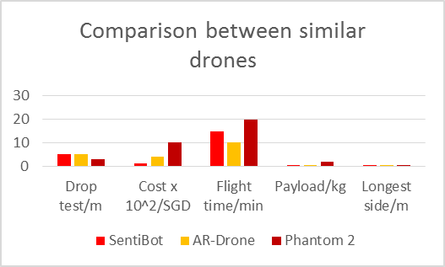

References
[1]- OSU UAS. (2012). UFRO. Available: https://unmanned.okstate.edu/ufro Last accessed 29/12/2015.

[2]- Miwa Suzuki. (2011). Japanese inventor develops flying sphere drone. Available: http://phys.org/news/2011-08-japanese-inventor-sphere-drone.html. Last accessed 12/11/2015.

[3]- Christopher M. Cianci, Xavier Raemy, Jim Pugh, Alcherio Martinoli. (2007). Communication in a Swarm of Miniature Robots: The e-Puck as an Educational Tool for Swarm Robotics. SpringerLink. 4433 (1), pp 103-115
[4]- Gerardo Beni. (2005). From Swarm Intelligence to Swarm Robotics.SpringerLink. 3342 (1), pp 1-9.

[5]- Mondada, F. Autonomous Syst. Lab., Ecole Polytech. Fed. de Lausanne, Switzerland Gambardella, L.M. ; Floreano, D. ; Nolfi, S. ; Deneuborg, J.-L. ; Dorigo, M.. (2005). The cooperation of swarm-bots: physical interactions in collective robotics. SpringerLink. - (1), 21 - 28.

[6]- Manuele Brambilla , Eliseo Ferrante, Mauro Birattari, Marco Dorigo. (2013). Swarm robotics: a review from the swarm engineering perspective. SpringerLink. 7 (1), pp 1-41.

